EXPERIMENT 3

DML Commands – INSERT, SELECT

Aim
To perform Data Manipulation Language (DML) commands such as INSERT and SELECT in the Hospital database.

Description:
Data Manipulation Language (DML) statements are used for managing data within schema objects. DML Commands: Insert, Select
- INSERT - insert data into a table
- SELECT - retrieve data from the a database

Questions

1) Populate the PATIENT table with your own data.
Patient_ID | Patient_Name | Age | Gender | Disease | Phone_No
P001 | Arun | 25 | M | Fever | 9876543210
P002 | Priya | 22 | F | Diabetes | 9876543211
P003 | Rahul | 30 | M | Asthma | 9876543212
P004 | Sneha | 28 | F | Migraine | 9876543213
P005 | Karthik | 35 | M | Typhoid | 9876543214

2) Populate the DOCTOR table with your own data.
Doctor_ID | Doctor_Name | Gender | DOB | Specialization | Phone_No | Department
D001 | Ravi | M | 1985-04-12 | Cardiology | 9876500001 | Cardiology
D002 | Priya | F | 1988-07-20 | Neurology | 9876500002 | Neurology
D003 | Kumar | M | 1982-11-15 | Orthopedics | 9876500003 | Orthopedics
D004 | Anitha | F | 1990-02-25 | Pediatrics | 9876500004 | Pediatrics
D005 | Suresh | M | 1986-09-10 | General Medicine | 9876500005 | General

3) Populate the DEPARTMENT table with your own data.
Dept_ID | Dept_Name | Dept_Head
DEP01 | Cardiology | Ravi
DEP02 | Neurology | Priya
DEP03 | Orthopedics | Kumar
DEP04 | Pediatrics | Anitha
DEP05 | General | Suresh

4) Populate the APPOINTMENT table with your own data.
App_ID | Patient_ID | Doctor_ID | App_Date | App_Time | Room_No
A001 | P001 | D001 | 2026-08-10 | 10:00:00 | R101
A002 | P002 | D002 | 2026-08-10 | 11:00:00 | R102
A003 | P003 | D003 | 2026-08-11 | 10:30:00 | R103
A004 | P004 | D004 | 2026-08-11 | 12:00:00 | R104
A005 | P005 | D005 | 2026-08-12 | 09:30:00 | R105

OUTPUTS:

1)
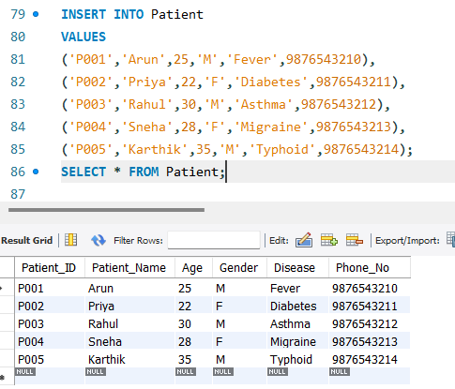
2)
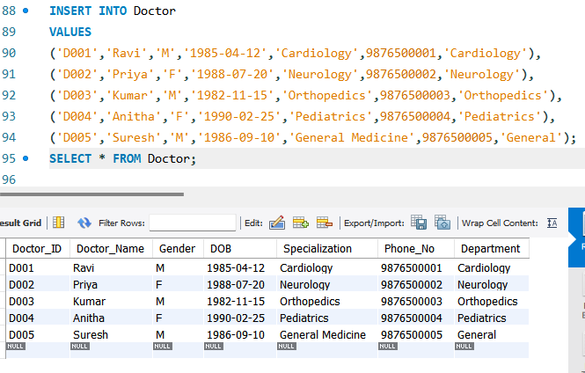

3)
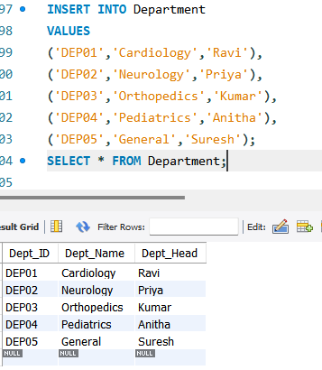

4)
